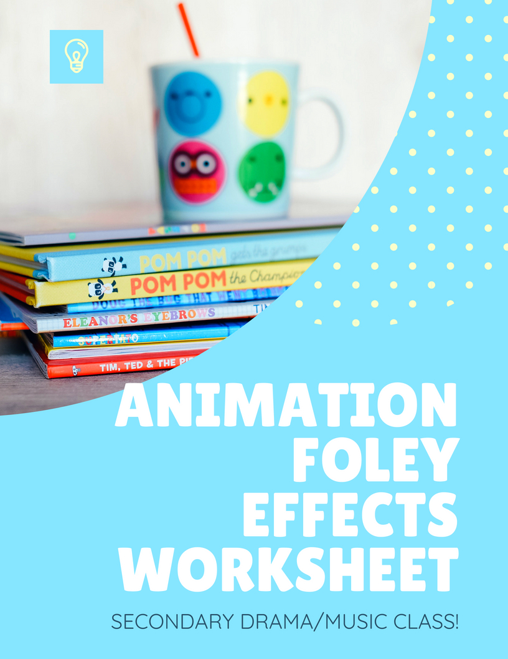

Teacher’s Notes

Start with video of an animated show/movie. Have students listen for sound effects.

Play a video of a Foley Artist demonstrating how effects are made.

Ex. <https://www.youtube.com/watch?v=E0pOLukIB4s>

Have students complete the following worksheet with creative ways to make the following Foley Effects.

Ex. #3 Baby footsteps on a hardwood floor- Put socks on hands and tap thumbs on piece of wood

National Arts Standards

Anchor Standard 2: Organize and develop artistic ideas and work.

Enduring Understanding: Theatre artists work to discover different ways of communicating meaning.

Essential Question(s): How, when, and why do theatre artists’ choices change?

TH:Cr2-3. a. Participate in methods of investigation to devise original ideas for a drama/theatre work.

Animation Foley Effects

What items would you use to create the following sound effects?

1. Robot cracking his knuckles
2. Sad bumblebee
3. Baby footsteps on a hardwood floor
4. Monkey peeling a banana
5. Elephant dribbling a basketball with his trunk

6. Balloon popping on a cactus

1. Dog jumping on a trampoline
2. Fish blowing up a balloon animal underwater
3. Tasmanian devil trying to pick out his clothes for school
4. Giant sloth from prehistoric times going to a new stomping grounds